Hunter Soil-ClikTM Weights & Measures

American:

 | Master Carton  H" | Master Carton  L" | Master Carton  W" | Master Carton Weight | Units per MC | MC Bar Code | Unit Carton  H” | Unit Carton  L" | Unit Carton  W" | Unit Carton Weight | Unit Bar Code | Item Number
Catalog # | (CH) | (CL) | (CW) | lbs | per (CA) |  |  |  |  | lbs
SOILCLIK | 7 | 18.5 | 12.6 | 10 lbs | 12 | 4 06 11698 02006 5 | 1.96 | 8.85 | 6.22 | .83 | 0 06 11698 02006 7 | 78687
SCPROBE | 8.86 | 18.9 | 11.22 | 15 lbs | 100 | 4 06 11698 02005 8 | 4.3 | 5.9 | bagged | .15 | 0 06 11698 02005 0 | 78686
SCMOD | 9.64 | 18.50 | 13.18 | 12 lbs | 20 | 4 06 11698 02004 1 | 1.77 | 8.85 | 6.22 | .6 | 0 06 11698 02004 3 | 78685

International (SI Units)

 | Master Carton  H mm | Master Carton  L mm | Master Carton  W mm | Master Carton Weight | Units per MC | MC Bar Code | Unit Carton  H mm | Unit Carton  L mm | Unit Carton  W mm | Unit Carton Weight | Unit Bar Code | Item Number
Catalog # | (CH) | (CL) | (CW) | kg | per (CA) |  |  |  |  | kg
SOILCLIK | 178 | 470 | 320 | 4.53 | 12 | 4 06 11698 02006 5 | 50 | 225 | 158 | .38 | 0 06 11698 02006 7 | 78687
SCPROBE | 225 | 480 | 285 | 6.8 | 100 | 4 06 11698 02005 8 | 110 | 150 | bagged | .068 | 0 06 11698 02005 0 | 78686
SCMOD | 245 | 470 | 335 | 5.44 | 20 | 4 06 11698 02004 1 | 45 | 225 | 6.22 | .272 | 0 06 11698 02004 3 | 78685
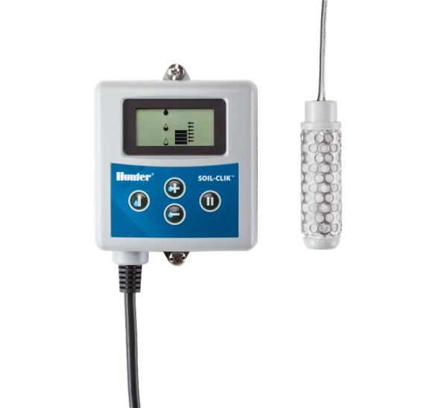
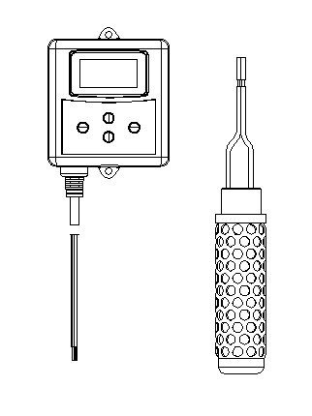
Soil Clik
SC-MOD
SC-PROBE

